WebstaurantStore Outlet Products Page Performance Task and Performance Analysis

Task:

Using JMeter, generate a performance report for a load test of Outlet product pages. The load test should run with a maximum of 5 RPM for a duration of 15 minutes, using a randomized sampling of product pages. The report should provide an assessment of the performance of these pages along with an explanation of the included metrics.

You may obtain sample pages using the following URL, which lists all available Outlet products under the heading “WebstaurantStore Scratch and Dent Outlet.” Clicking on any of the items will load the product page you will be testing.

<https://www.webstaurantstore.com/outlet.html>.

Requirements:

* Runnable on Windows 10
* JMeter

Summary:

Given task was completed successfully within the scope and with some assumptions and liberties. Since the test was performed from an old computer from Florida and additionally due to latency on where the servers are located, the actual performance might vary significantly. The given task could be done multiple ways, I have chosen the simplest method to complete with no extra dependencies. (Please do check if any plugins are missing before running in test machine) Overall performance of product pages appear to be very good with only few transactions observed spikes and variance in standard deviation though the load was consistent.

* Test script was developed using Jmeter5.5 and executed in windows 10 to meet the requirement.
* Load test was performed with 2 user threads and 15 seconds ramp up time.
* A constant throughput timer was used to accomplish 5 RPM and the actual test performed at 5.1 RPM
* The test was run for 15 minutes and 76 samples were requested during the process
* Randomized sampling of product pages resulted in selecting 13 different products out of 15 available in total with some products being accessed more frequently.

Apdex shows the overall performance satisfaction index with Tolerance threshold set by 500ms and Frustration threshold at 1.5 seconds by default in JMeter properties and can be modified to business SLA. So, any response time less than 500ms will be shown as 1(highest satisfaction) and higher than 1.5 seconds is considered bad performance. Only Outlet page was in the score range of 0.5

[**APDEX (Application Performance Index)**](https://en.wikipedia.org/wiki/Apdex)

| **Apdex** | **T (Toleration threshold)** | **F (Frustration threshold)** | **Label** |
| --- | --- | --- | --- |
| **0.717** | **500 ms** | **1 sec 500 ms** | **Total** |
| 0.500 | 500 ms | 1 sec 500 ms | webstaurantstore.com_S&D_Outlet_page |
| 0.750 | 500 ms | 1 sec 500 ms | product_185B48GSY1BH/66027 |
| 0.833 | 500 ms | 1 sec 500 ms | product_178CBE72HC/66017 |
| 0.875 | 500 ms | 1 sec 500 ms | product_372G60436RRN/66021 |
| 0.875 | 500 ms | 1 sec 500 ms | product_178SS1RHC/66013 |
| 0.875 | 500 ms | 1 sec 500 ms | product_178SSUD2R/66015 |
| 1.000 | 500 ms | 1 sec 500 ms | product_415C80BAJADA/66009 |
| 1.000 | 500 ms | 1 sec 500 ms | product_499UDF0140AA/66025 |
| 1.000 | 500 ms | 1 sec 500 ms | product_178SSUC72RHC/66029 |
| 1.000 | 500 ms | 1 sec 500 ms | product_178A49FHC/66037 |
| 1.000 | 500 ms | 1 sec 500 ms | product_351GMCPG24NL/66035 |
| 1.000 | 500 ms | 1 sec 500 ms | product_499UFP0350AA/66023 |
| 1.000 | 500 ms | 1 sec 500 ms | product_560MSC66AA/66011 |
| 1.000 | 500 ms | 1 sec 500 ms | product_522ETSG2472/66039 |

Response times appear to be consistent but due to random selection choice some of the transactions are executed more times than others. Due to this some products TPS (Transactions per second) is indicated as zero (i.e., less than 0.1 TPS). The median to 99 percentile difference should be less to indicate consistent performance. Only Outlet product page has wide visible difference but within the threshold of 1.5 seconds.

Sometimes a critical business transaction might take longer times (complete purchase) while other transactions perform well and therefore never the focus should be on Total transaction average performance. That is not the case here as there are no critical transactions.

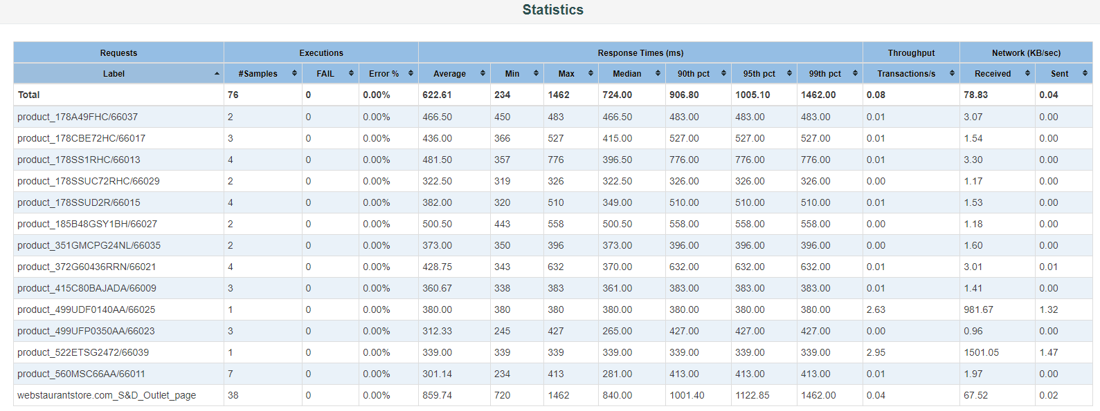

The spike that is observed in blue color is the Outlet page launch transaction along with another product selection is an indication of delay, could be a network issue when you compare with latency graph below that.

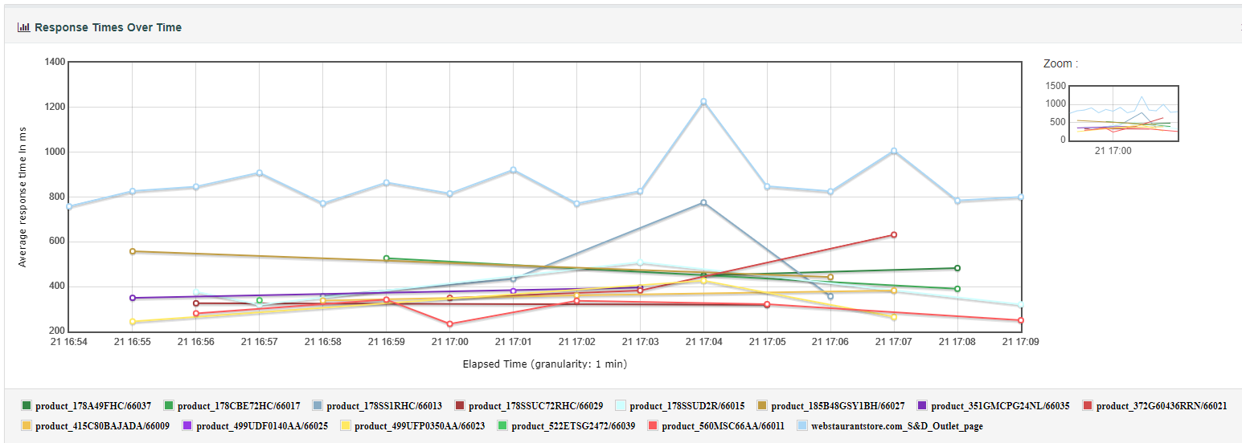

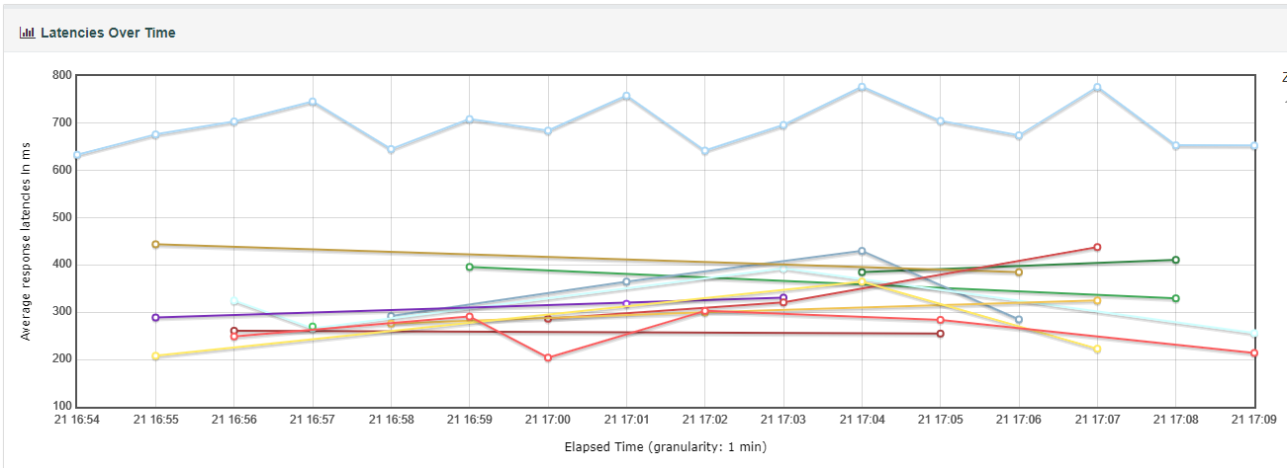

TPS of 0.83 indicates that the requirement of 5 RPM is met. (0.83 x 60 =4.98 approx.)

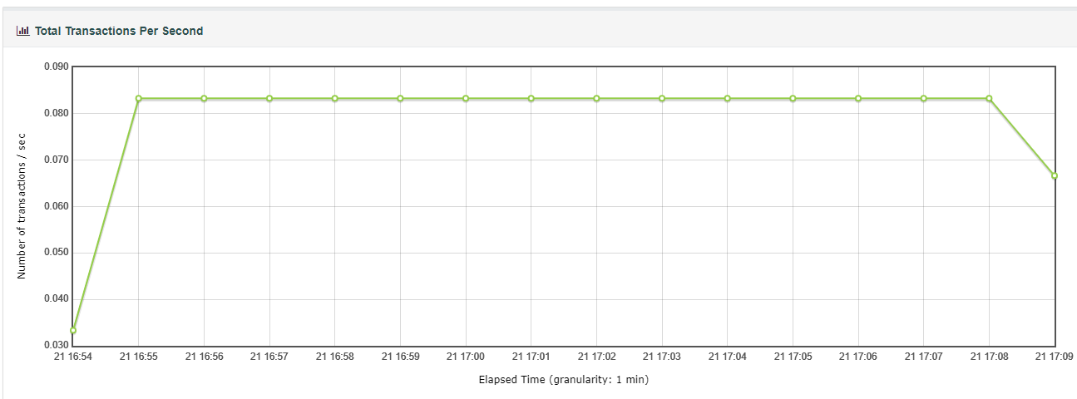

Please refer to html report and summary reports for more clear understanding and feel free to ask any questions.